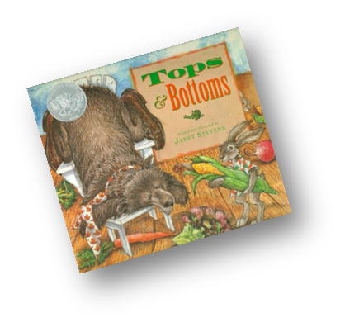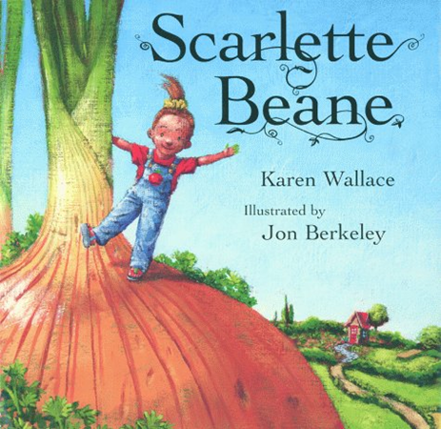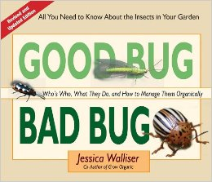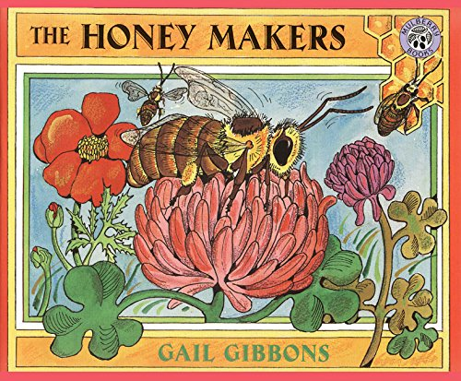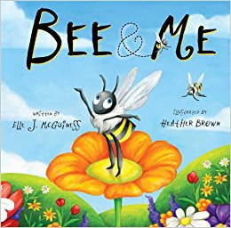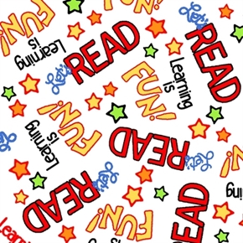

**2017 Kidz Klub Book List**

Books available at Howard County Library:

**Bee & Me**\*

Elle J. McGuinness

**Gardening for Butterflies**\*

Robert Michael Pyle

**Good Bug/ Bad Bug**\*\*

Jessica Walliser

**Henrietta’s Guide to Caring for Your Chickens**

Isabel Thomas, J 636.5 T

**Hide with the Ladybugs**

Karen Latchana Kenney, J 638.5 K

**Making Butterfly Gardens**

Dana Meachen Rau, J 638.5 R

**Vegetables**

Weekly Reader Early Learning Library, J 635 K

**Wiggly Earthworms**

Natalie Lunis, J 592.6 L

**The Honey Makers**\*

Gail Gibbons

**Tops & Bottoms**\*\*

Janet Stevens

Books from Kidz Klub Library:

**Scarlette Beane**

Karen Wallace

**Grow! Raise! Catch!**

Shelley Rotner

* Southwest Arkansas Beekeepers (SWABK) Special Collection at Howard County Library

**NDOG Special Collection at Howard County Library